# Applicant and Job Matching Platform

–– team 026 Dayta

### **Summary:**

Our Applicant and Job Matching Platform facilitate the process of job searching by integrating advanced machine learning algorithms to provide personalized job recommendations matched to each user’s unique profile. This platform allows users to efficiently discover and apply to appropriate job openings that match their skills, experience, and preferences. Through a user-friendly interface developed using React, and a robust backend powered by Java and Spring Boot, alongside a Python-driven recommendation algorithm, the platform offers a responsive experience. By simplifying the application process and enhancing job discovery through intelligent matching, our platform stands out as a crucial tool in navigating the job market.

### **Application Description:**

The Applicant and Job Matching Platform is designed to improve the job search process. At its core, the platform features a machine learning recommendation system that analyzes user profiles—including location, skills, and job preferences—to suggest the most suitable job listings.

From a technical standpoint, the platform is structured with a React-based frontend that provides an engaging and interactive user experience. The backend, built with Java using the Spring Boot framework, ensures data management and server-side logic. A Python engine supports the recommendation algorithms which utilize data from the MySQL database. The platform supports full CRUD (Create, Read, Update, Delete) operations, allowing users to maintain dynamic profiles and read from job listings effectively. Additionally, keyword search functionality lets users refine their job search based on specific criteria such as job titles, locations, and other relevant keywords. This blend of advanced technology and user-centered design makes the platform a powerful tool in the employment sector, enhancing better job matches and simplifying the application process for users.

Our application helps job seekers shorten the time it takes to find a job. Job seekers can create and fill in their own personal information and the system will automatically list suitable positions for job seekers according to the position situation. In addition, job seekers can manually enter the positions they are interested in to get more comprehensive job information. Our site is similar to LinkedIn's job search site, but LinkedIn automatically recommends users based on their profile information and has some latency. Our users can modify their information at any time and the job information will change immediately. At the same time, we do not ask users to fill in the job intention, because we will only match the most suitable job for users according to their actual abilities.

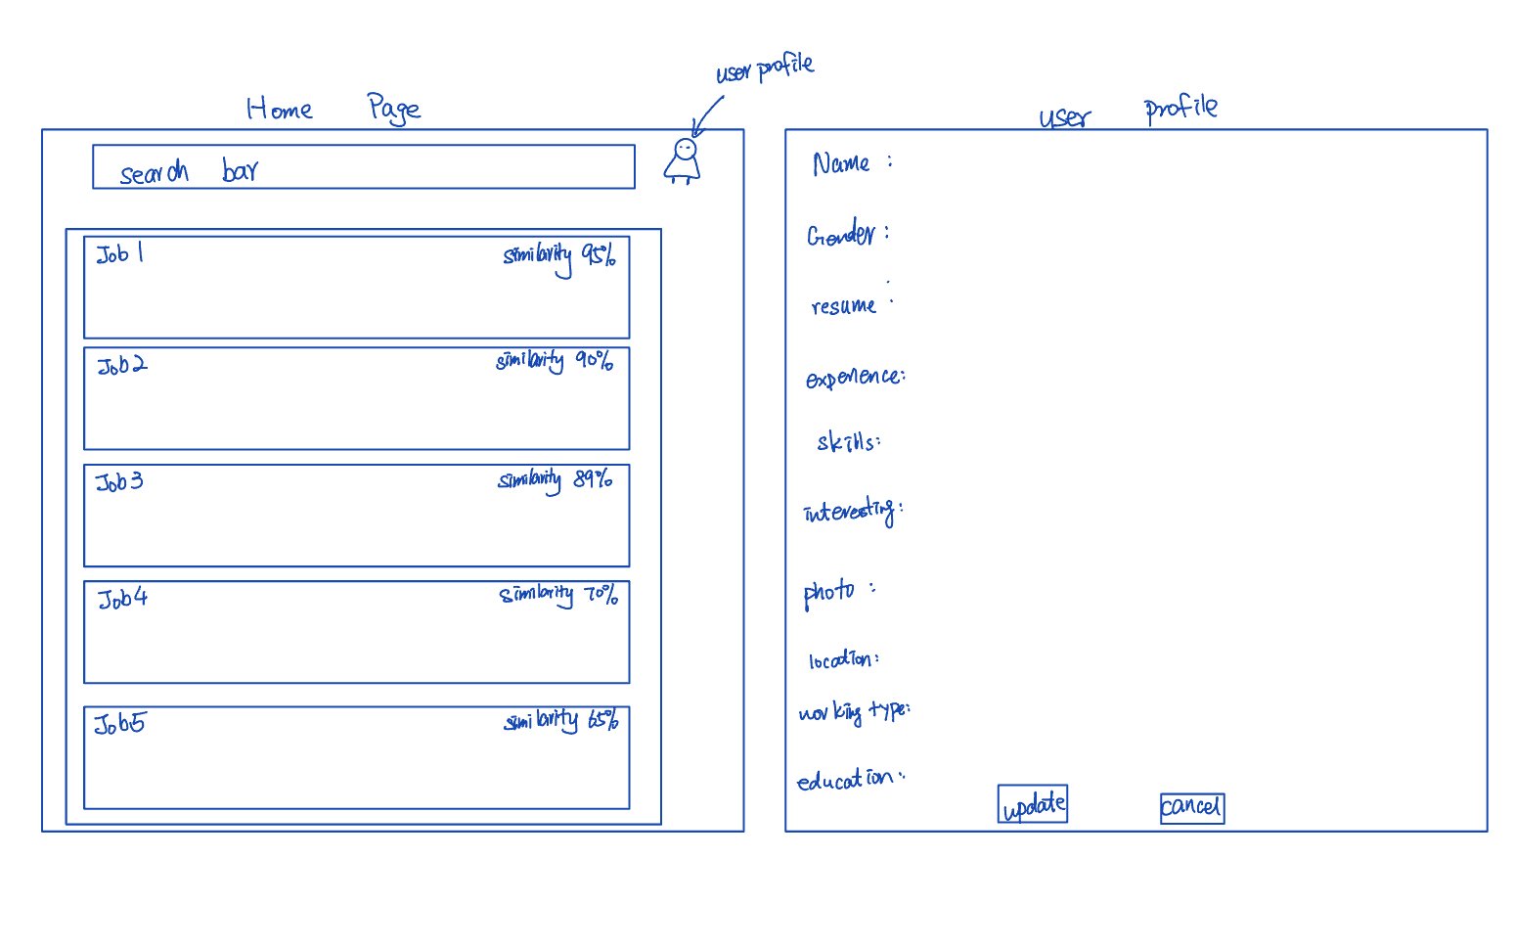figure 1: UI mockup

### 

### **Detailed Functionality Description:**

**Authentication:**

### Our Applicant and Job Matching Platform provides a seamless and intuitive experience for job seekers, focusing on personalized job discovery and application efficiency. Users begin by registering an account using their email or via OAuth options like Google or LinkedIn. Upon logging in, they are directed to a personalized dashboard that showcases job recommendations tailored to their profiles.

#### 

**CRUD Operations:**

* Create: Users can register and create their profiles.
* Read: Enables searching and displaying job listings.
* Update: Users can modify their profiles as needed.
* Delete: Provides the option to remove user profiles from the platform.

### Users can create and manage their profiles by entering personal information, education, work experience, skills, and job preferences. The platform allows them to upload resumes and cover letters, which enhance the accuracy of job matching. Full CRUD (Create, Read, Update, Delete) operations are supported, enabling users to create profiles and applications, read job listings and details, update their information and application materials, and delete accounts or saved jobs as desired.

**Keyword Search Functionality:**

### 

### The job search functionality includes advanced keyword search with filters for location, company, job type, and other criteria. Job listings display essential information such as title, company, location, salary range, and a brief description.

**Machine Learning recommendation system:**

### Our sophisticated recommendation system is a core feature, utilizing machine learning algorithms and natural language processing to analyze user profiles and job descriptions. This system delivers personalized job matches that update in real-time as users modify their profiles or preferences. Users can provide feedback on recommendations, allowing the system to learn and improve over time.

**UI Interface:**

### The user interface is designed for ease of navigation, with key pages including Home, Dashboard, Profile, Job Listings and Settings. A consistent navigation bar and intuitive layout enable users to move effortlessly between different sections of the platform. By integrating these functionalities, our platform streamlines the job search process, making it more efficient, personalized, and user-friendly.

### **Usefulness:**

Job application is a hassle. Take software summer interns as an example, applicants need to constantly check whether their company of interest has opened up the role they will be interested in. Current job boards like LinkedIn have limitations - some companies do not post their open roles on LinkedIn. Also for people looking specifically in certain types of roles (like Software Engineer Intern), they will see lots of irrelevant job lists. When companies like Google or Meta open up their intern roles, someone looking for an intern role in the tech industry surely wants to be notified - but LinkedIn’s recommendations do not support that level of specialization. If someone follows Google on LinkedIn, that person’s email will be flooded by irrelevant position notifications like Senior Engineer or Data Analyst.

Our platform addresses these challenges by enforcing **role specialization**. If a user is looking specifically for software summer internships, only those positions will be displayed and forwarded. When major tech companies like Google or Meta open up their internship roles, users will be immediately notified without having to wade through irrelevant job notifications. This ensures a streamlined job search experience, eliminating the clutter and helping applicants stay on top of the most relevant opportunities in real time.

### **Creative Component:**

Our platform's creative component lies in its advanced recommendation system, which integrates machine learning algorithms and natural language processing (NLP) techniques to deliver personalized job matches. We utilize a hybrid recommendation approach that combines content-based filtering to analyze both user profiles and job descriptions. By processing user-entered data such as preferences, alongside real-time job market data, our system intelligently suggests the most relevant job opportunities.

A technically challenging aspect is the seamless integration of Python-based machine learning models with our Java Spring Boot backend and React frontend. We plan to develop an inter-process communication mechanism to allow our Java backend to interact with the Python recommendation engine efficiently.

**Data Sources (Realness) :**

To build a robust and realistic system, we will use multiple real-world datasets:

1. **Job Recommendation Dataset （File Format: csv, Cardinality：84,090, 23 attribute per record）:** This dataset contains a variety of job postings and applicant profiles, providing a foundation for building our recommendation system. ([link](https://www.kaggle.com/datasets/kandij/job-recommendation-datasets/data))
2. **Public IT Job Dataset (File Format: csv, Cardinality: 8,552, 4 attributes per record) :** This dataset focuses on job postings in the IT sector and will help refine the recommendation system for technology roles. ([link](https://www.kaggle.com/code/thedocs/it-job-recommendation/notebook))
3. **New Graduate Positions Dataset ( File Format: csv, Cardinality: ~300, 5 attributes per record ) :** This dataset, sourced from GitHub, contains real-world job openings specifically for new graduates. ([link](https://github.com/SimplifyJobs/New-Grad-Positions?tab=readme-ov-file))

These datasets have different attribute count, so we need to implement our way to combine these information together and build our schemas.

**Work Distribution:**

**Benhao Lu:** Backend development (Spring Boot, Database integration, job matching logic).

**Yuyang Wang:** Backend development (Machine learning model, NLP integration, recommendation engine).

**Xin Xu:** Frontend development (React interface, job search functionality, UX design).

**Zijin Zhou:** Frontend development (React components, interactive visualization, UI/UX refinement).